

UNIVERSITY OF GONDAR

FACULITY OF INFORMATICS

DEPARTEMENT OF COMPUTER SCIENCE

**WEB BASED ONLINE TENDERING MANAGEMENT SYSTEM FOR UNIVERSITY OF GONDAR**

INDUSTRIAL PROJECT

BY

NAME OF STUDENTS IDNO

1. Aderaw Yeshewas GUR/3668/08
2. Adugna Wacho GUR/3670/08
3. Alayu Melak GUR/3677/08
4. Yohaniss mengistu GUR/4034/08
5. Sosina Esubalew GUR/3965/08
6. Abeba Atinkut GUR/1296/07

PROJECT ADVISOR: Habtamu Michael

December 2018

# CERTIFICATE

I certify that this BSC industrial project entitled Web based online tendering management system for University of Gondar by:

NAME OF STUDENTS SIGNATURE

1. Aderaw Yeshewas ----------------
2. Adugna Wacho ----------------
3. Alayu Melak ---------------
4. Yohannis Mengistu ----------------
5. Sosina Esubalew ----------------
6. Abeba Atinkut ----------------

Is approved by me for submission. I certify further that, to the best of my knowledge, the project represents work carried out by the students.

**_________________ ___________________________**

Date Name and signature of Supervisor

# DECLARATION

This is to declare that this project work which is done under the supervision of Habtamu Michael and having the title Web based online tendering management system for University of Gondar is the sole contribution of:

1. Aderaw Yeshewas
2. Adugna Wacho
3. Alayu Melak
4. Yohaniss mengistu
5. Sosina Esubalew
6. Abeba Atinkut

No part of the project work has been reproduced illegally (copy and paste) which can be considered as Plagiarism. All referenced parts have been used to argue the idea and have been cited properly. We will be responsible and liable for any consequence if violation of this declaration is proven.

Date: _____________________  
**Group Members:**

Full Name Signature

1. Aderaw Yeshewas ___________
2. Adugna Wacho ___________
3. Alayu Melak ___________
4. Yohaniss mengistu ___________
5. Sosina Esubalew ___________
6. Abeba Atinkut __________

# ACKNOWLEDGMENT

First of all, we would like to thank our almighty God, who gives us love, healthy and wisdom. Next the project team expresses a great appreciation and gratitude to our Advisor Mr. Habtamu Michael for his valuable guidance, moral support, valuable suggestion and constant encouragement. We also want to thank University of Gondar purchasing employees Mr. Abebe Hailu and Mr. Seid Mohammed, who gave us information about tendering system at University of Gondar that we are asking for our project. Finally, we would like to thank commuter science department project committee for providing us suitable condition to complete this project.

# ABSTRACT

This document is prepared for web based online tendering management system for University of Gondar. It concerns with the description of the existing tendering system and the development of the new system. Web based online tendering management system mainly provides effective, fast and accurate data processing and controlling of information.

The main aim of developing online tendering management system is to allow easier coordination of activities from the beginning of the tendering process up to the end of the process. This system has many beneficiaries such as bidders can register, submitting technical documents, place bid price, downloading tender document, view result online and also they can view tender advertisements and notifications on time. Purchasing employees are another beneficiary of the system by performing activities online. Those activities are like posting tender advertisement, uploading tender document, evaluating technical document, generating report, extending the opening date of the tender when the tender opening date is not working day or holiday and canceling the tender if the organization make better option.

In our proposed online tendering management system the organization can publish their tender advertisement and the bidder can participate if he/she is interested to purchase or sell goods and services.

Table of Contents

CERTIFICATE i

DECLARATION ii

ACKNOWLEDGMENT iii

ABSTRACT iv

ACRONYMS AND ABBREVIATIONS ix

CHAPTER ONE 1

1. PROJECT PROPOSAL 1

1.1. Introduction 1

1.2. Background of the organization 1

1.3. Statement of the problem 1

1.4. Objectives of the project 1

1.4.1. General objective 1

1.4.2. Specific objective 1

1.5. Scope and limitation of the project 1

1.5.1. Scope of the project 1

1.5.2. Limitation of the project 1

1.6. System development methodology 1

1.6.1. Investigation (fact-finding) methods 1

1.6.2. System development tools 1

1.7. Significance of the project 1

1.8. Beneficiaries of the system 1

1.9. Time schedule 1

CHAPTER TWO 1

2. REQUIREMENT ANALYSIS 1

2.1 Introduction 1

2.2 Current System 1

2.2.1 Major function of the current system 1

2.2.2 Problem of the existing System 1

2.3 Requirement Gathering 1

2.3.1 Requirement Gathering Methodologies 1

2.3.2 Results Found 1

2.3.3 Business Rules 1

2.3.4 Assumptions and Dependencies 1

2.4 Proposed System 1

2.4.1 Overview of the proposed system 1

2.4.2 Functional Requirements 1

2.4.3 Non-Functional Requirements 1

2.5 System Model 1

2.5.1 Scenario 1

2.5.2 Use case Model 1

2.5.3 Activity diagram 1

2.5.4 Object model 1

2.5.5 User interface 1

CHAPTER THREE 1

3. SYSTEM DESIGN 1

2.6 Introduction 1

2.7 Current software architecture 1

2.8 Proposed software architecture 1

2.8.1 Overview 1

2.8.2 Subsystem decomposition 1

2.8.3 Hardware/software mapping 1

2.8.4 Persistent data management 1

2.8.5 Access control and security 1

2.8.6 Subsystem services 1

2.9 Detailed Class Diagram 1

2.10 Packages/Models 1

REFERENCE 1

**List of tables**

Table 1.1 Software tools 1

Table 1.2 Time schedule 1

Table 2.1 Login use case description 1

Table 2.2 Post tender advertisement use case description 1

Table 2.3 Upload tender document use case description 1

Table 2.4 View bidder use case description 1

Table 2.5 Send tender document request use case description 1

Table 2.6 view request use case description 1

Table 2.7 Download tender document use case description 1

Table 2.8 Place bid use case description 1

Table 2.9 Cancel tender use case description 1

Table 2.10 Extend opening date use case description 1

Table 2.11 Close tender use case description 1

Table 2.12 Open tender use case description 1

Table 2.13 Approve sample use case description 1

Table 2.14 Evaluate Technical document use case description 1

Table 2.15 Generate notification use case description 1

Table 3.1 Access control matrix 1

**List of figures**

Figure 2‑1 use case diagram 1

Figure 2‑2 Activity diagram for Login 1

Figure 2‑3 Activity diagram for Post tender advertisement 1

Figure 2‑4 Activity diagram for upload tender document 1

Figure 2‑5 Activity diagram for place bid 1

Figure 2‑6 Class diagram 1

Figure 2‑7 Sequence diagram for Login 1

Figure 2‑8 Sequence diagram for post tender advertisement 1

Figure 2‑9 Sequence diagram for upload tender document 1

Figure 2‑10 Sequence diagram for Place bid 1

Figure 2‑11 State chart diagram for login 1

Figure 2‑12 State chart diagram for Bidder registration 1

Figure 2‑13 User interface for login 1

Figure 2‑14 User interface for registration 1

Figure 3‑1 Architecture of the Proposed System 1

Figure 3‑2 Component diagram 1

Figure 3‑3 Deployment diagram 1

Figure 3‑4 E-R diagram 1

Figure 3‑5 Detailed class diagram 1

Figure 3‑6 Package diagram 1

# ACRONYMS AND ABBREVIATIONS

UML: Unified Modeling Language

HTML: Hypertext Markup Language

CSS: Cascading Style Sheet

PHP: Hypertext Preprocessor

SQL: Structured Query Language

CPU: Central Processing Unit

RAM: Random Access Memory

SPMP: Software Project management Plan

SRS: Software Requirement Specification

SDD: Software Design Description

STD: Software Test Documentation

HTTP: Hypertext Transfer protocol

USB: Universal Serial Bus

VAT: Value Added Tax

ERCA: Ethiopian Revenues and Customs Authority

Admin: Administrator

ID: Identification

# CHAPTER ONE

# PROJECT PROPOSAL

## Introduction

Technology has improved our lives in every aspect. It also used to increase communication directly with one another via internet. Manually driven systems are now being overtaken by computerized system. Now a day’s computer does most of the work through software. Specifically technology enables tendering system fast, accurate and reliable by reducing the drawback of manual handling system.

Tender is a document that the organization publishes to announce his request for certain goods or services and through this process an offer is made by the organization to accomplish work at an acknowledged price by the bidder []. The current system of tendering at University of Gondar is both cost & time consuming because of manual working. University of Gondar needs to manage a manual system for tender as well as bidders also. In the current manual system the purchasing officer first prepares the tender and advertises in the newspaper, radio, television and etc. Then bidder shows his/her interest for registration and buys the tender document from the company. After that the bidder has to place bid to the company within specific time. The company then opens the tender and evaluates it and award notifies the tender. To do this we want to propose online tendering management system. Online system has much significance like avoiding paper work, time saving and the system provides reliable tender.

## Background of the organization

University of Gondar is one of the oldest Universities in Ethiopia, until 2003 it was known as Gondar College of Medical Science, is the oldest medical school in Ethiopia, established as the Public Health College in 1954. In 2010 the university offered 42 undergraduate and 17 postgraduate programs. As of 2016 the university offers 56 undergraduate and 64 postgraduate. These are organized under the College of Medicine and Health Sciences, College of Business and Economics, College of Natural and Computational Science, College of Social Science and Humanities and Faculty of Veterinary medicine and Faculty of Agriculture and three schools (School of Law, School of Technology and School of Education.

This institution has five branch campuses these are maraki campus, Atse Tewodros campus, Atse Fasil campus and Teda campus. The University has steadily grown and evolved into one of the top education institution in the country today.

## Statement of the problem

University of Gondar current tendering system has no online and modern database management system which use for computerized handling of tendering. Since all tendering works at University of Gondar is provided manually, this requires too much paper, a lot of time and also takes a vast amount of manpower. Data handling and data manipulation also not secured and it may expose to damage easily. Due to this there is work overload on employees and bidders also. Therefore to reduce these problems we are going to develop online system by using computerized system and by giving privilege for authorized user to perform their activities by accessing the system online. Currently tendering at University of Gondar is facing many problems due to the use of manual handling system.

* High tender advertising, paper & overhead costs.
* Bidders have to wait long time to get the tender document.
* Bidders who live far from the organization have lower participation rate.
* Prone to human errors and corruption.
* Tender process takes too much time.

We are going to improve the drawbacks of the existing system by developing an automated, user friendly and interactive graphical user interface system which will:-

* Manage time effectively.
* Make the data secure.
* Make the data error free.
* Use available resources effectively.

## Objectives of the project

### General objective

The general objective of this project is to develop web-based online tendering management system for University of Gondar.

### Specific objective

To achieve the general objectives of the project, the proposed system consists of the following specific objectives:

* Collect the information about the existing system.
* Analyze the current system.
* Identify the problems of the existing system.
* Suggest alternative solutions in order to address the current problem.
* Build new interface design for the proposed system.
* Build new database design for the proposed system.
* Implement the proposed system in efficient way.
* Test the new system and deliver to the organization and recommended further work.

## Scope and limitation of the project

### Scope of the project

This project will be developing new web based online tendering management system only for University of Gondar. There are many types of tender these are open tender, limited tender, direct purchasing etc. Among those our system focuses only open tender because in University of Gondar purchasing and selling activities performs mostly on open type of tender. Our web based online tendering management system supports system functionalities like posting Tender advertisement, uploading and downloading tender document, registration and participation of bidder, evaluating Technical document and financially, generating result, notification and reports.

### Limitation of the project

Our system is limited only in the process of web based tendering system for University of Gondar, but does not include the following.

* The system cannot provide any payment because in Ethiopia context online payment is not possible.
* The system doesn’t include contracts, delivery and hire/rent because of insufficient time and system complexity.
* And also the system is not applicable for visually impaired persons.

## System development methodology

We identify and understand the topic first and then we stated the problem. Next we had some idea to solve the problems and then we change our idea to software. This will be achieved by software development, which involves eliciting system requirements specification, system design, system implementation and system testing.

The methodology we used for developing the system is iterative model. Because of:-

* When we use iterative model requirements that we already used can be modified.
* Iterative model is more flexible.
* Iterative model is less costly to change the scope and requirement without altering the entry requirement.

### Investigation (fact-finding) methods

The Method and techniques used to analyze the existing system and designing online system includes interview, document analysis and observation []. Those methods which help us to gather the required data to analyze our project and those methods selected due to the time and the organization’s willingness.

1. **Interview**

We have gathered information by interviewing the University of Gondar purchasing employees about the existing system of the tender and we also interviewed bidders. We prepared open ended questions and administered to the respondents to enable them to state their views freely.

1. **Document analysis**

This technique provides information on how the existing system works .Therefore Study the documents that are related to the existing system of tendering system. We could know the pre request of bidder to participate and the content of the tender document. The information via document analysis is very vital to use as input for the development of our project.

1. **Observation**

We observe office activities of purchasing and finance employee at University of Gondar. We observe preparing tender document, storing bidders file. These are used for understanding of how the current system operates and process.

### System development tools

**Software tools:**

|  |  |
| --- | --- |
| **Activities** | **Tools/Programs** |
| Documentation | Microsoft Word 2010 |
| Presentation | Microsoft PowerPoint 2010 |
| Browsers­­ | Baidu browser, Mozilla Firefox |
| Drawing UML diagrams | E-draw max |
| Client side coding | HTML |
| Design and layout | CSS |
| Client side scripting | JavaScript |
| Server side scripting | PHP |
| Database server | MySQL |

Table 1.1 Software tools

**Hardware tools:**

* **Flash**
* **Hard disk**
* **Laptop**
  + Processor: Intel® Core(TM) 2 Duo CPU @ 2.53GHz 2.54GHz
  + Installed memory(RAM): 4GB

## Significance of the project

The main significance of the system is:-

* It provides the organization to purchase and sell goods and services easily.
* Easy to search, retrieve, update and delete data for an authorized user.
* This system allows the bidder to participate on a tender everywhere.
* Reduce the workload of employee and bidder.
* It is a very efficient way of getting tender document and place bid online.
* The system provides the organization to avoid improper resource consumption like paper, pen.
* This system used to reduce corruption.
* It will provide security mechanism to data that are unauthorized users will not gain access to the system.

## Beneficiaries of the system

Beneficiaries of this system are the following:-

**Employee:**

* Simple process for posting tender advertisement.
* Can distribute tender document easily.
* Reduce the workload of the office activities such as preparation of tender document.
* Avoiding data loss.
* Enhance security mechanisms to protect Technical document.

**Bidders:**

* Improves time usage.
* They can get tender document easily.
* They can place bid easily.
* Decrease the workload and tiredness.
* They can get notifications.
* The bidder can get the tender result easily.
* They can also see tender advertisement easily when new tender publish.

**University of Gondar:**

* Reduce the extravagancy.
* Increase system performance
* Introduce the organization into technology.
* Enables the institution more competent in technology.

## Time schedule

Table 1.2 Time schedule

# CHAPTER TWO

# REQUIREMENT ANALYSIS

## Introduction

First we will gather thorough knowledge of the existing system to have clear idea about the system. For this, we will arrange interview session with a pre-selected questioner to purchasing officer who announce tender, document analysis and direct observation. We were study on the standard tender document published by University of Gondar. From our gathering knowledge we will find the pitfalls of the existing system. We were review the system to find a suitable solution to overcome these pitfalls. After this we have the requirements in our hand and we could turn these requirements into formal analysis and design specifications. Then we determine the requirements for the proposed system.

## Current System

The existing system of tendering performs different function manually and this leads to security weakness. Because of the manual work, the current system is time consuming. These are the result of lack of computerized system or web based system.

### Major function of the current system

Even if the existing tendering system performs its activities manually, it has different major functions.

* Post the Tender advertisement using magazine paper, board, television, radio or other media.
* Register and participate bidders on a tender in a paper filling form.
* Sell tender document to the bidders.
* Opens the tender.
* Select the best sample of the product.
* Evaluate Technical document
* Evaluate financially based on bidder price.
* Select the best bidder for tender.

### Problem of the existing System

As we discussed above University of Gondar tendering system is manual. Generally it has a lot of problems for buying and selling goods or services listed in section 1.3 above such as tender document distribution, post Tender advertisement. Over load of work on the employee and bidders is also seen on the current system of tendering at University of Gondar.

The existing system problems are as follows:-

* Lack of accurate data ,
* The system has problems related to security.
* It takes long time to search data.
* manpower
* Lack of efficiency, effectiveness.
* Since it operable manually it uses large amount of space to store data.

## Requirement Gathering

### Requirement Gathering Methodologies

The requirement of the system is gathered using primary data collecting techniques. These are listed below.

1. **Interview**

We have gathered information by interviewing the University of Gondar purchasing employees about the existing system of the tender and we also interviewed bidders. We prepared open ended questions and administered to the respondents to enable them to state their views freely.

1. **Document analysis**

This technique provides information on how the existing system works .Therefore Study the documents that are related to the existing system of tendering system. We could know the qualification of bidder to participate and the content of the tender document. The information via document analysis is very vital to use as input for the development of our project.

1. **Observation**

We observe office activities of purchasing and finance employee at University of Gondar. We observe preparing tender document, storing technical document. These are used for understanding of how the current system operates and process.

### **Results Found**

Due to the method used to find the requirement, we can be concluded that all tendering works in University of Gondar is done manually. Even though they use computers, but there is no online system. This implies that a lot of mistakes might appear in the system. Hence introducing web based system to the University of Gondar employee and to the bidder is mandatory.

Results found while gathering requirements regarding the problem of the current tendering system in University of Gondar is.

* The purchasing officer **Mr. Abebe Hailu** says “preparing tender document has huge work load and extravagancy because of paper use”.
* The purchasing and finance director **Mr. Seid Mohammed** says “99% tendering is for purchasing, and the rest 1% is for sale”.
* One bidders say that “tendering activity is very difficult because of all activity of tendering process is done manually”.

### **Business Rules**

In University of Gondar there are rules and policy, which used to govern activities performed in the tendering system.

**BR1:** Bidders should fulfill the pre request to participate on a tender. The pre requests are:-

* Bidders must have renewed trade license.
* Bidders must have bank guarantee.
* Bidders must be VAT subscriber.
* Bidders must be taxpayer.
* Bidders must have support letter which is given from ERCA officer.

**BR2:** Bidders should pay payment to get tender document.

**BR3:** If Tender advertisement is posted, tender should be stay on some specific days.

**BR4:** The organization has a right to cancel the tender completely or partially.

**BR4:** If the tender opening date is on holiday or not on working day the tender must be open on the next working day.

### Assumptions and Dependencies

The project team assumed about computer skill, user must be trained basic computer functionalities and the user must have the basic knowledge of English language. We assumed internet access, the speed of communication channel or internet performance must be good in order to perform activities quickly. The system depends on the software components and hardware components which are needed for the system and also it depends on internet access.

## Proposed System

The proposed system is designed to reduce the drawbacks of the existing tendering system. The system shall be responsible for secure database management, providing to make the operations and activities more accurate; the system needs to be computerized and should perform activities online.

In order to overcome the existing problem we are making this system as online where every bidder to get better facilities by his/her own computer or laptop.

### Overview of the proposed system

After looking the current system and identifying the problems occurred during over all activities of the tendering at University of Gondar, the project team has decided to develop web based online tendering management system for University of Gondar. New system will solve the problem and limitation of the current tendering system seen above. After developing the new system it is fully flagged online at anytime, anywhere. The proposed system will use the major functionality of the existing system and able to advance in accordance with speed, reliability, performance and efficiency.

* The proposed system Minimize the extravagancy of the institution.
* The system provides quality work with minimum cost.
* The proposed system improves time usage means.
* The proposed system will improve speed, efficiency and reliability of tendering process.
* The system reduces the work load of purchasing officer, finance officer and bidders.
* The proposed system is a very efficient way to place bid online.

### Functional Requirements

Functional Requirements are those that refer to the functionality of the system, i.e., what services it will provide to the user []. Statements of services the system should provide how the system should react to particular inputs and how the system should behave in particular situations [].

The new Online tendering management system will be more satisfactory because of the following functionalities:-

* The system shall allow Admin to register employee and manage account.
* The system shall allow purchasing officer to post Tender advertisement.
* The system shall allow user or bidder registration.
* The system shall allow the bidder to view Tender advertisement.
* The system shall allow purchasing officer to upload tender document.
* The system shall allow the bidder to send tender document request.
* The system shall allow finance officer to approve tender document request.
* The system shall allow the bidder to download tender document.
* The system shall allow the bidder to place bid.
* The system shall allow purchasing officer to cancel the tender.
* The system shall automatically close the tender when scheduled event come upon.
* The system shall allow purchasing officer to extend the tender opening date.
* The system shall allow purchasing officer to open the tender.
* The system shall allow professionals to approve sample product.
* The system shall allow purchasing officer to evaluate Technical document.
* The system shall perform financial evaluation and generate result.
* The system shall allow the user and officer to view result.
* The system shall generate the notification.
* The system shall allow user to give feedback to admin for system modification.

### Non-Functional Requirements

Non-functional requirements describe user-visible aspects of the system that are not directly related with the functional behavior of the system []. These requirements indirectly affect the performance of the system

#### User Interface and Human Factors

The new proposed system simple and interactive user interface components should be part of the system. This user friendly interface requirement of the system will be available in any end user and system administrator interface of the application. It can be access using English language.

#### Documentation

We prepare software project management plan (SPMP), software requirement specification (SRS), software design description (SDD), software test documentation (STD) document with full implementation. The system has a guide book describes how to use the system for users.

#### Hardware consideration

The system should have to be run on all computers. The hardware required to run this system are laptop, desktop and server.

#### Performance Characteristics

**Supportability:**Since our system is developed by PHP and java script, the code can run in any browsers.

**Response Time:** The system under normal condition should display results as quickly as possible.

**Concurrent Processing:** The proposed system can handle multiple users at a time.

#### Error Handling and Extreme Conditions

The system have an error handling mechanisms that is, as errors occur it will not stop functioning rather provide error manages and back to the previous page to give chance to enter again the data and process the task by beyond the error. The system should handle exceptions listed below

* Login error: The system will generate an error message in order to fill again properly.
* Duplicating username at registration time.
* Validation error: for example when the user enters special character in alphanumeric text field.

#### Quality Issues

**Usability:** The system should be easy to use for every user.

**Availability**: The system should be available for all working hours.

**Correctness**: The results of the function are pure and accurate.

**Reliability:** The performance of the system is better which will increase the reliability.

#### System Modifications

In the future it will be new technology invention, therefore the system should be modify or upgrade by system developers for further modification and enhancement of the applications. Means developers add the new feature of the system when needed.

#### Physical Environment

Our system is affected by physical environment such like natural disaster occurred, extreme weather condition and etc. The proposed system will be affected by internal physical environment like attack by viruses. To solve these problems our team members deploys the system in two or more server computers to protect the data from damage.

#### Security Issues

The system provides access privilege to an authorized user.

* The system should authenticate the users by filling user name and passwords form.
* The system has a capacity that the admin can lock his private data that will not be access by other user.
* There will be proper security regarding to the accessing of data.

#### Resource Issues

Hardware Resource:

* Server
* Processor: 2.54 GHz
* RAM(installed memory): 2.00 GB
* Hard disk: 500 GB

Software Resource:

* Windows operating system
* browser

## System Model

### Scenario

Scenarios are an instance of a use case explaining a concrete major set of action []. Scenario is a description that illustrates, step by step, how a user is intending to use a system, essentially capturing the system behavior from the user's point of view [].

**Scenario 1:**

**Scenario name:** Add business category

**Actor:** Admin

**Flow of event**

The system displays login page then admin enters a valid username and password and click login button. After admin login to the system, admin select Add business category link to add new business category, system displays filling form. Then admin fills form and click add button.

**Scenario 2:**

**Scenario name:** View Tender advertisement

**Actor:** bidder

**Flow of event**

The system displays login page then bidders enter a valid username and password and click login button. After bidders login in to the system, bidder select tenders link to view tenders advertisement, then the system displays the tenders list.

**Scenario 3:**

**Scenario name:** Send tender document request

**Actor:** bidder

**Flow of event**

The system displays login page then bidders enter a valid username and password and click login button. After bidder login in to the system, bidder select tender link and then bidders select the tender he/she want to participate and click Send tender document request link after this system displays form bidder fill form and click send button.

**Scenario 4:**

**Scenario name:** Place bid

**Actor:** bidder

**Flow of event**

The system displays login page then bidders enters a valid username and password and click login button. After bidder login in to the system, bidder select tender link then system lists all active tenders and then bidders select the tender he/she want to participate and click place bid link, after this system display filling form. Then bidder fills the form and click submit button.

**Scenario 5:**

**Scenario name:** Post Tender advertisement

**Actor:** Purchasing officer

**Flow of event**

The system displays login page then purchasing officer enters a valid username and password and click login button. After purchasing officer login in to the system, purchasing officer select new tender link the system displays filling form, after this purchasing officer fill the form correctly and click post button.

**Scenario 6:**

**Scenario name:** Upload tender document

**Actor:** Purchasing officer

**Flow of event**

The system displays login page then purchasing officer enters a valid username and password and click login button. After purchasing officer login in to the system, purchasing officer select tender link and then select the tender. Then purchasing officer select upload tender document link the system displays form after this purchasing officer fill the form correctly and click upload button.

**Scenario 7:**

**Scenario name:**  View request

**Actor:** Finance officer

**Flow of event**

The system displays login page then finance officer enters a valid username and password and click login button. Then finance officer select the tender then the system displays tender information and bidders list who wants tender document. After this finance officer check bidders list who pay payment in cash and click approve button then system sends tender document to the bidder.

### Use case Model

A use case defines a goal-oriented set of interactions between external users and the system under consideration or development it is the functionality of the system or the service provided by the system []. In order to create relevant use cases for the system, we used the following actors and use cases for the system:

Admin:-

* Manage account
* Register employee
* Add business category
* View feedback

Purchasing officer:-

* Post Tender advertisement
* Upload tender document
* View bidders
* Cancel tender
* Extend opening date
* Open tender
* Evaluate Technical document
* Generate report
* View result
* Send feedback
* Change password

Bidder:-

* Register
* View Tender advertisement
* Send tender document request
* Download tender document
* Place bid
* View result
* View notification
* Send feedback
* Change password

Finance officer:-

* View request
* Send feedback
* Change password

Professional:-

* Approve samples
* Send feedback
* Change password

Time:-

* Generate notification
* Close tender

#### Use case diagram

Figure 2‑1 use case diagram

#### Description of Use-Case Model

Use case description provides critical information needed to understand in what context the use cases are and briefly explain how the functionalities precede using natural language in a step wise manner.

|  |  |  |
| --- | --- | --- |
| Use case name | Login | |
| Actor | Admin, Purchasing officer, finance officer, bidder, professional | |
| Description | This use case is about log in to the system | |
| Pre-condition | Users must have username and password | |
| Post condition | The user login to the system | |
| Basic course of action | Actor action | System response |
| Step 1: User starts the system  Step 3: User enters username and password and click login button | Step 2: System displays login form  Step 4: System verifies input value  Step 5: System displays user page |
| Alternative course of action | 4.1: If the entered value is invalid then the system will generate an error message in order to fill again properly. | |

Table 2.1 Login use case description

|  |  |  |
| --- | --- | --- |
| Use case name | Post Tender advertisement | |
| Actor | Purchasing officer | |
| Description | This use case is about post or publishes tender advertisement. | |
| Pre-condition | Purchasing officer must login to the system. | |
| Post condition | Tender advertisement is posted | |
| Basic course of action | Actor action | System response |
| Step 1: purchasing officer login to the system  Step 3: purchasing officer select new tender link.  Step 5: purchasing officer fills form correctly and click post button. | Step 2: System displays page.  Step 4: System displays form.  Step 6: System verifies input.  Step 7: System displays tender is posted successfully message. |
| Alternative course of action | 6.1: If the entered value is invalid then the system will generate an error message in order to fill again properly. | |

Table 2.2 Post tender advertisement use case description

|  |  |  |
| --- | --- | --- |
| Use case name | Upload tender document | |
| Actor | Purchasing officer | |
| Description | This use case is about upload tender document. | |
| Pre-condition | Purchasing officer must login to the system. | |
| Post condition | Tender document is uploaded | |
| Basic course of action | Actor action | System response |
| Step 1: purchasing officer login to the system  Step 3: purchasing officer select tenders link.  Step 5: purchasing officer select tender he/she want to upload tender document.  Step 7: purchasing officer select upload tender document link.  Step 9: purchasing officer fills form correctly and click upload button. | Step 2: System displays page.  Step 4: System displays all tenders.  Step 6: System displays tender information.  Step 8: System displays form.  Step 10: System verifies input value.  Step11: System displays document is uploaded successfully message. |
| Alternative course of action | 10.1: If the entered value is invalid then the system will generate an error message in order to fill again properly. | |

Table 2.3 Upload tender document use case description

|  |  |  |
| --- | --- | --- |
| Use case name | View bidder | |
| Actor | Purchasing officer | |
| Description | This use case is about generating report. | |
| Pre-condition | Purchasing officer must login to the system. | |
| Basic course of action | Actor action | System response |
| Step 1: Purchasing officer select tender link.  Step 3: Purchasing officer select the tender that he/she want to view bidders of that tender.  Step 5: Purchasing officer select view bidder link. | Step 2: System displays all tenders.  Step 4: System displays tender information.  Step 6: System displays bidder company name, contact person and security code which generated from system randomly. |

Table 2.4 View bidder use case description

|  |  |  |
| --- | --- | --- |
| Use case name | Send tender document request | |
| Actor | Bidder | |
| Description | This use case is about send tender document request. | |
| Pre-condition | Bidder must login to the system and view Tender advertisement. | |
| Basic course of action | Actor action | System response |
| Step 1: Bidder login to the system  Step 3: Bidder select tenders link.  Step 5: Bidder select tender he/she want to send tender document request.  Step 7: Bidder select send tender document request link.  Step 9: Bidder fills form correctly and click send button. | Step 2: System displays page.  Step 4: System displays all tenders.  Step 6: System displays tender information.  Step 8: System displays form.  Step 10: System verifies input value.  Step11: System displays request sent successfully message. |

Table 2.5 Send tender document request use case description

|  |  |  |
| --- | --- | --- |
| Use case name | View request | |
| Actor | Finance officer | |
| Description | This use case is about view tender document requests sent from bidders. | |
| Pre-condition | Finance officer must login to the system. | |
| Post condition | Finance officer views all tender document requests | |
| Basic course of action | Actor action | System response |
| Step 1: Finance officer login to the system  Step 3: Finance officer click tender link.  Step 5: Finance officer select the tender he/she want to view request.  Step 7: Finance officer click view request link.  Step 9: Finance officer select bidders who pay tender document payment in cash and click approve button. | Step 2: System displays page.  Step 4: System lists all tenders.  Step 6: System displays tender information.  Step 8: System displays all bidders who want tender document.  Step 8: System displays approved successfully message. |
| Alternative course of action | 9.1: If there is a bidder who were not pay payment, then finance officer omit them. | |

Table 2.6 view request use case description

|  |  |  |
| --- | --- | --- |
| Use case name | Download tender document | |
| Actor | Bidder | |
| Description | This use case is about download tender document. | |
| Pre-condition | Bidder must login to the system and pay tender document payment. | |
| Post condition | Tender document request sent | |
| Basic course of action | Actor action | System response |
| Step 1: bidder login to the system  Step 3: bidder click tender link.  Step 5: bidder select tender he/she want to download tender document.  Step 6: bidder click download tender document button. | Step 2: System displays page.  Step 4: System lists all tenders.  Step 6: System displays tender information.  Step 7: Browser downloads tender document. |

Table 2.7 Download tender document use case description

|  |  |  |
| --- | --- | --- |
| Use case name | Place bid | |
| Actor | Bidder | |
| Description | This use case is about place bid. | |
| Pre-condition | Bidder must login to the system. | |
| Post condition | Bidder place bid. | |
| Basic course of action | Actor action | System response |
| Step 1: bidder login to the system  Step 3: bidder select tender link.  Step 5: bidders select the tender he/she want to participate.  Step 7: bidder select place bid link.  Step9: bidder fills the form and click submit button | Step 2: System displays page.  Step 4: system lists all tenders.  Step6: system display tender information.  Step8: system display filling form.  Step 10: System verifies the input value.  Step 11: System displays successfully message. |
| Alternative course of action | 10.1: If the entered value is invalid then the system will generate an error message in order to fill again properly. | |

Table 2.8 Place bid use case description

|  |  |  |
| --- | --- | --- |
| Use case name | Cancel tender | |
| Actor | Purchasing officer | |
| Description | This use case is about cancel tender. | |
| Pre-condition | Purchasing officer must login to the system. | |
| Post condition | Tender is canceled successfully. | |
| Basic course of action | Actor action | System response |
| Step 1: purchasing officer login to the system  Step 3: purchasing officer click tender link.  Step 5: purchasing officer select the tender he/she want to cancel.  Step 7: purchasing officer click cancel tender button  Step 9: purchasing officer fill form and click cancel button | Step 2: System displays page.  Step 4: System display tenders list.  Step 6: System displays tender information.  Step 8: System displays form.  Step 10: System verifies input value.  Step 11: System displays tender canceled successfully message. |

Table 2.9 Cancel tender use case description

|  |  |  |
| --- | --- | --- |
| Use case name | Extend opening date | |
| Actor | Purchasing officer | |
| Description | This use case is about extending opening date. | |
| Pre-condition | Purchasing officer must login to the system. | |
| Post condition | Tender opening date is extended. | |
| Basic course of action | Actor action | System response |
| Step 1: purchasing officer login to the system  Step 3: purchasing officer click tender link.  Step 5: purchasing officer select the tender to extend opening date.  Step 7: purchasing officer click extend opening date button.  Step 9: purchasing officer fill form and click extend button. | Step 2: System displays page.  Step 4: System display tenders list.  Step 6: System displays tender information.  Step 8: System displays form.  Step 10: System displays successful message. |

Table 2.10 Extend opening date use case description

|  |  |
| --- | --- |
| Use case name | Close tender |
| Actor | Time |
| Description | This use case is about tender closing. |
| Pre-condition | The given time must be finish. |
| Post condition | Tender is closed. |
| Basic course of action | Actor action |
| Step1: The tender automatically closed when the scheduled event is come upon. |

Table 2.11 Close tender use case description

|  |  |  |
| --- | --- | --- |
| Use case name | Open tender | |
| Actor | Purchasing officer | |
| Description | This use case is about tender opening. | |
| Pre-condition | Purchasing officer must login to the system and tender must be closed. | |
| Post condition | Tender is opened. | |
| Basic course of action | Actor action | System response |
| Step 1: purchasing officer login to the system  Step 3: purchasing click tender link.  Step 5: purchasing officer select the tender he/she want to open.  Step 7: purchasing officer click open tender button. | Step 2: System displays page.  Step 4: System display tenders list.  Step 6: System displays tender information. |
| Alternative course of action | 7.1: If the tender were not closed, the system displays error message. | |

Table 2.12 Open tender use case description

|  |  |  |
| --- | --- | --- |
| Use case name | Approve sample | |
| Actor | Professional | |
| Description | This use case is about approves sample products. | |
| Pre-condition | Professional must login to the system and he/she must view samples manually. | |
| Basic course of action | Actor action | System response |
| Step 1: professional login to the system  Step 3: Professional click tender link.  Step 5: Professional select the tender.  Step 7: professional selects the bidder that has best product and click approve sample button. | Step 2: System displays page.  Step 4: System lists all tenders.  Step 6: System displays tender information and participant bidder’s security code generated from the system randomly.  Step 8: System displays approved successfully message. |

Table 2.13 Approve sample use case description

|  |  |  |
| --- | --- | --- |
| Use case name | Evaluate Technical document | |
| Actor | Purchasing officer | |
| Description | This use case is about evaluating Technical document. | |
| Pre-condition | Purchasing officer must login to the system and must open tender. | |
| Post condition | Bids evaluated successfully. | |
| Basic course of action | Actor action | System response |
| Step 1: purchasing officer login to the system  Step 3: purchasing officer open the tender.  Step 4: purchasing officer select evaluate Technical document link.  Step6: purchasing officer evaluates the document and click approve button. | Step 2: System displays page.  Step 5: System display Technical document.  Step 7: System displays approved successfully message. |
| Alternative course of action | 6.1: If the Technical document is invalid then the purchasing officer clicks deny button to reject the Technical document. | |

Table 2.14 Evaluate Technical document use case description

|  |  |
| --- | --- |
| Use case name | Generate notification |
| Actor | Time |
| Description | This use case is about sending notification. |
| Post condition | Notification sent |
| Basic course of action | Actor action |
| Step 1: notification automatically sent when the scheduled event come upon. |

Table 2.15 Generate notification use case description

### Activity diagram

Activity diagrams are graphical representations of [workflows](http://en.wikipedia.org/wiki/Workflow) of stepwise activities and actions with support for choice, iteration and concurrency []. Activities are states that represent the execution of a set of operations []. The completion of these operations triggers a transition to another activity. They can be used to represent control flow and data flow.

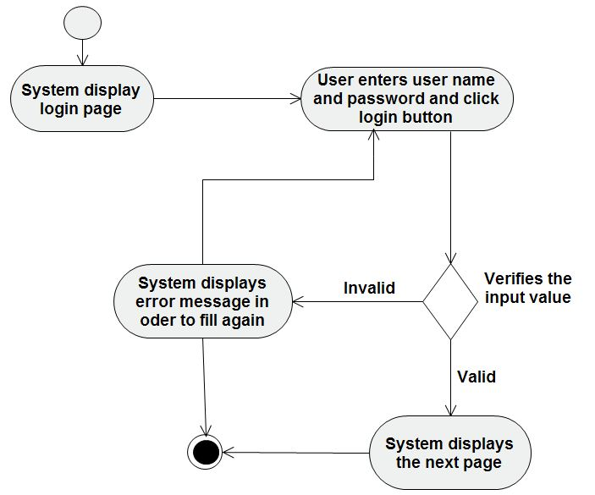

Figure 2‑2 Activity diagram for Login

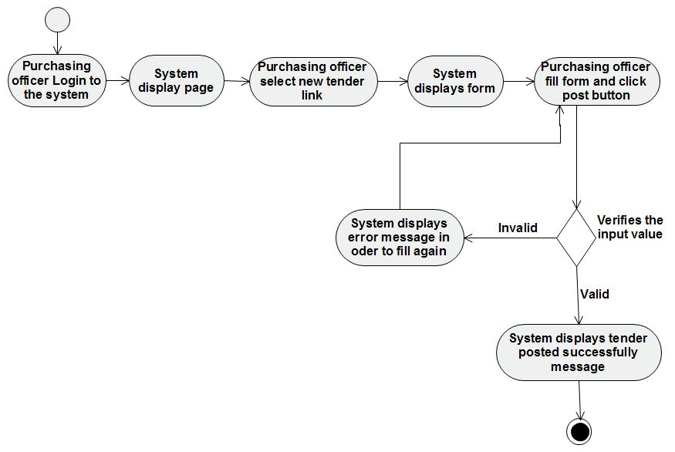

Figure 2‑3 Activity diagram for Post tender advertisement

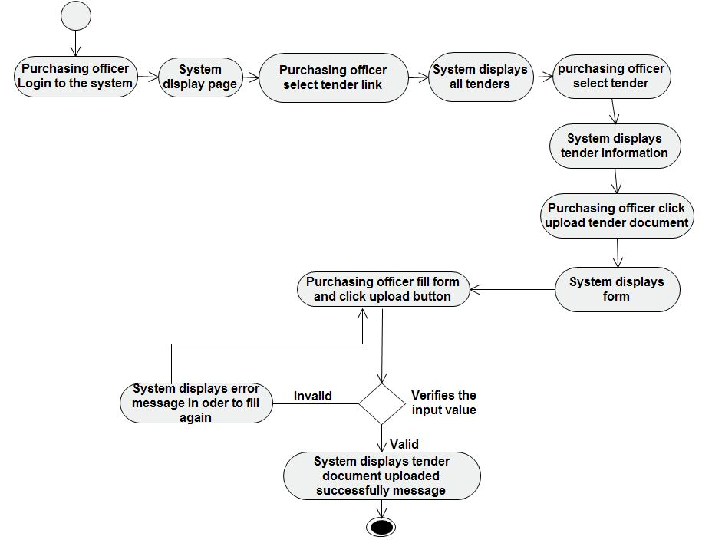

Figure 2‑4 Activity diagram for upload tender document

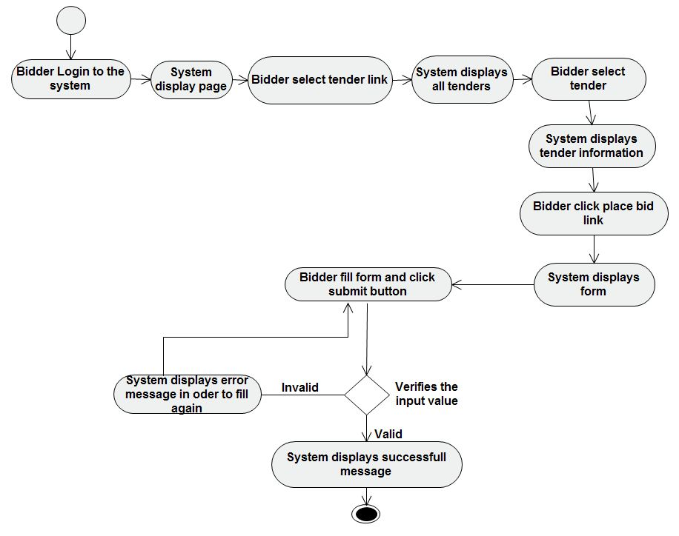

Figure 2‑5 Activity diagram for place bid

### Object model

Object model deals with object oriented of the system []. This includes, class diagram, relationship between these classes, methods in the class and properties.

#### Data dictionary

This gives a brief description of the field names used in the tables and what they define as per the databases.

|  |
| --- |
| **Entity object Attribute Description** |
| **Admin**  First_name Holds first name of admin  Middle_name Holds middle name of admin  Last_name Holds last name of admin  Admin_id Holds id number of admin  Email Holds email of admin  Username Holds username of admin  Password Holds password of admin |

|  |
| --- |
| **Entity object Attribute Description** |
| **Bidder** Company_name Holds name of Bidders Company  License_no Holds License number of Bidders Company  Contact person Holds contact person of Bidder Company  Address Holds address of Bidder Company  Email Holds email of contact person  Username Holds username of contact person  Password Holds password of bidder |

|  |
| --- |
| **Entity object Attribute Description** |
| **Purchasing officer**  First_name Holds first name of purchasing officer  Middle_name Holds middle name of purchasing officer  Last_name Holds last name of purchasing officer  Purchaser_id Holds id number of purchasing officer  Email Holds Email of purchasing officer  Username Holds username of purchasing officer  Password Holds password of purchasing officer |

|  |
| --- |
| **Entity object Attribute Description** |
| **Finance officer**  First_name Holds first name of finance officer  Middle_name Hold middle name of finance officer  Last_name Holds last name of finance officer  Finance_officer_id Holds id number of finance officer  Email Holds Email of finance officer  Username Holds username of finance officer  Password Holds password of finance officer |

|  |
| --- |
| **Entity object Attribute Description** |
| **Professional**  First_name Holds first name of professional  Middle_name Hold middle name of professional  Last_name Holds last name of professional  Professional_Id Holds id number of professional  Email Holds Email of professional  Username Holds username of professional  Password Holds password of professional |

|  |
| --- |
| **Entity object Attribute Description** |
| **Product** Product_name Holds the name of product  Product_id Holds identification number of document  Category Holds the business category of product  Price Holds the price of product  Lot_no Holds the lot number of the product |

|  |
| --- |
| **Entity object Attribute Description** |
| **Tender advertisement** Tender_id Hold the id number of advertisement  Transaction Holds action of sale or purchase  Opening_date Holds the closing date of the tender  Closing_date Holds the posting date of the tender  Description Holds the body of the advertisement. |

|  |
| --- |
| **Entity object Attribute Description** |
| **Tender document**  Document_no Holds identification number of document  Date Holds the uploading date of document  Description Holds the content of the document |

|  |
| --- |
| **Entity object Attribute Description** |
| **Technical document** Document_id Holds identification number of document  Company_name Holds the name of Bidder Company  Contact person Holds the name of contact person  Document_path Holds Path of the document  Date Holds the submission date of the file |

|  |
| --- |
| **Entity object Attribute Description** |
| **Feedback**  feedback_id Holds identification number of feedback  Sender_name Holds name of sender  Date Holds the date of sent  Message Holds the message of the feedback |

|  |
| --- |
| **Entity object Attribute Description** |
| **Notification** notice_id Holds identification number of notice  Date Holds the date of sent  message Holds the body of the notice |

#### Class modeling

Class diagram shows the main building block of [object oriented](http://en.wikipedia.org/wiki/Object_oriented) system. Class diagrams depict the static view of the model or part of the model, describing what attribute and behavior it has rather that detailing the methods for achieving operations []. Class diagrams are most useful to illustrate relationships between classes.

In the diagram, classes are represented with boxes which contain three parts:

* The top part contains the name of the class
* The middle part contains the attributes of the class.
* The bottom part contains the methods the class can execute.

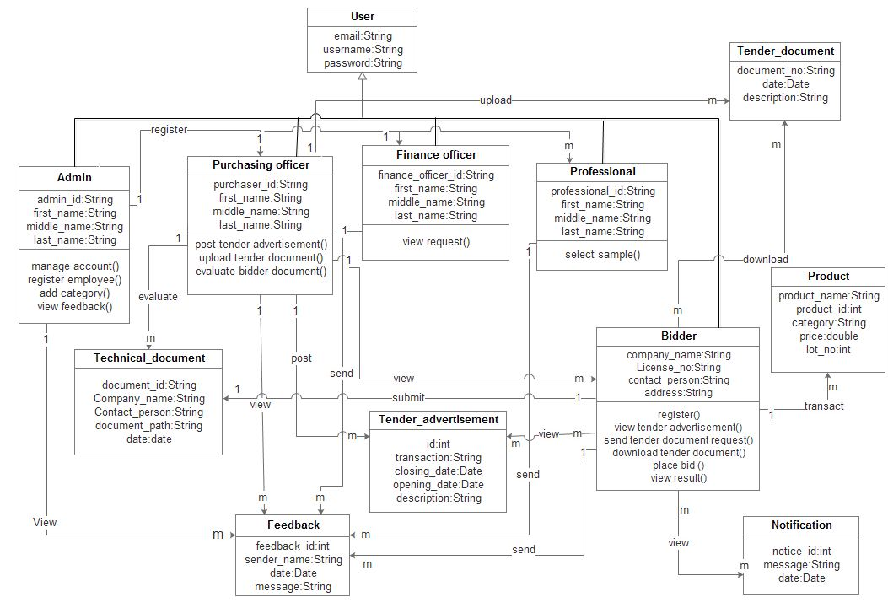

Figure 2‑6 Class diagram

**Sequence diagram**

A Sequence diagram is an [interaction diagram](http://en.wikipedia.org/wiki/Interaction_diagram) that shows how processes operate with one another and in what order []. It is a construct of a [Message Sequence Chart](http://en.wikipedia.org/wiki/Message_Sequence_Chart). A sequence diagram shows object interactions arranged in time sequence. It depicts the objects and classes involved in the scenario and the sequence of messages exchanged between the objects needed to carry out the functionality of the scenario. Sequence diagrams are typically associated with use case realizations in the logical view of the system under development []. Sequence diagrams are sometimes called event diagrams or event scenarios.

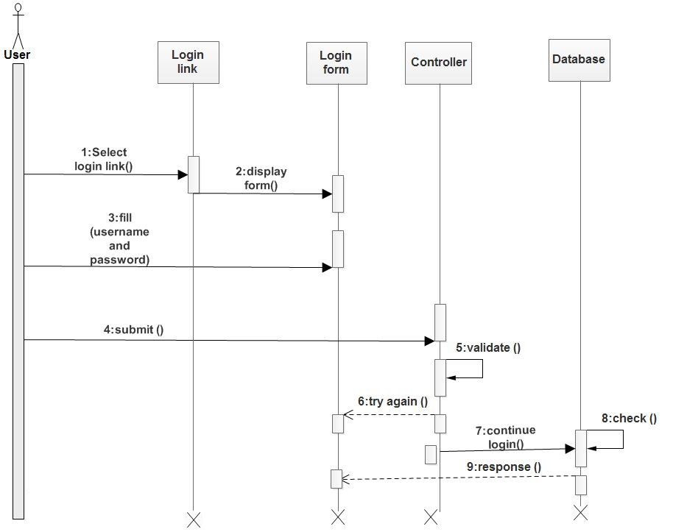

Figure 2‑7 Sequence diagram for Login

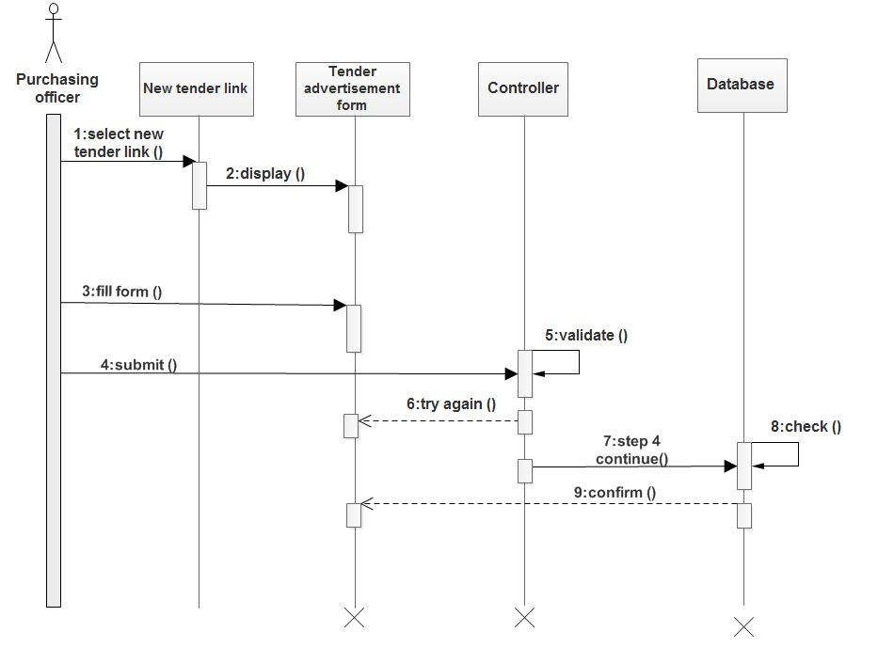

Figure 2‑8 Sequence diagram for post tender advertisement

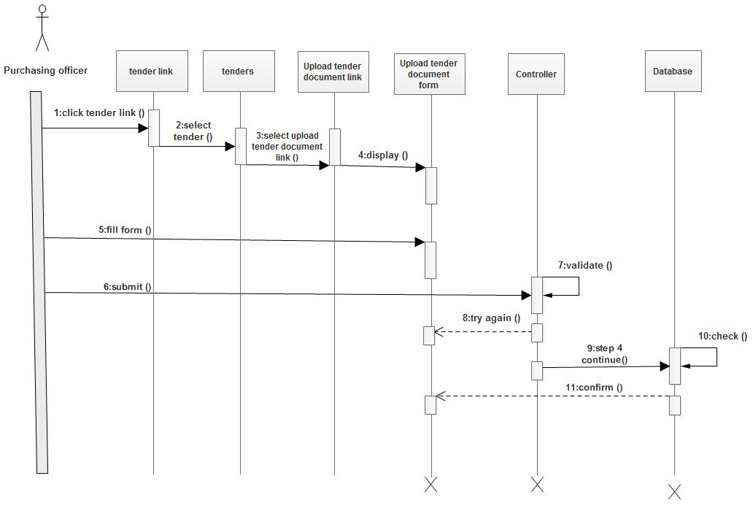

Figure 2‑9 Sequence diagram for upload tender document

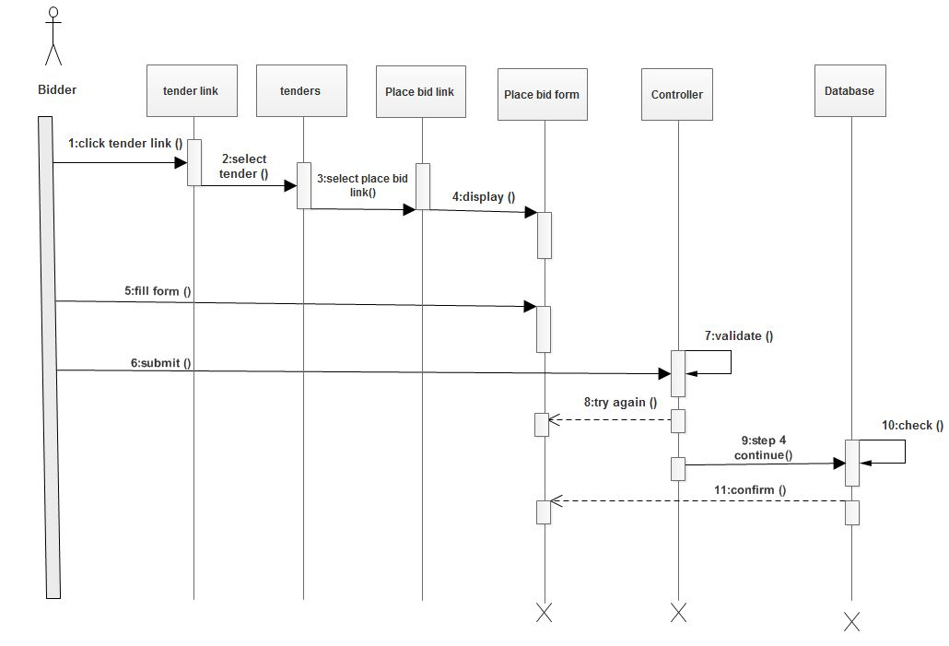

Figure 2‑10 Sequence diagram for Place bid

**State Chart Diagram**

State chart modeling is used to show the sequence of states that an object goes through, the events that cause the transition from one state to the other and the actions that result from a state change. A dynamic model showing changes of state of a single class over time in response to events along with its responses and actions.

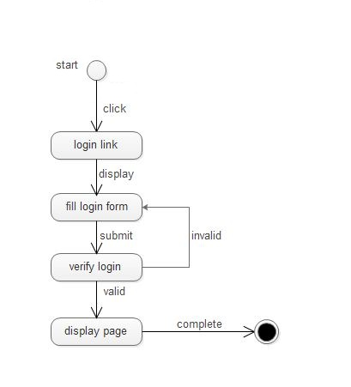

Figure 2‑11 State chart diagram for login

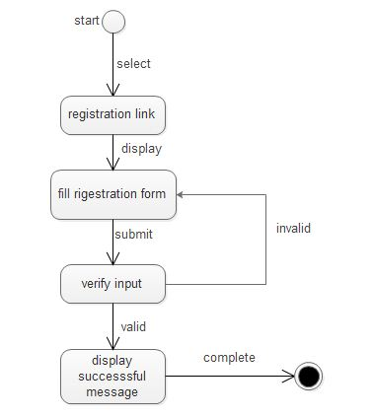

Figure 2‑12 State chart diagram for Bidder registration

### User interface

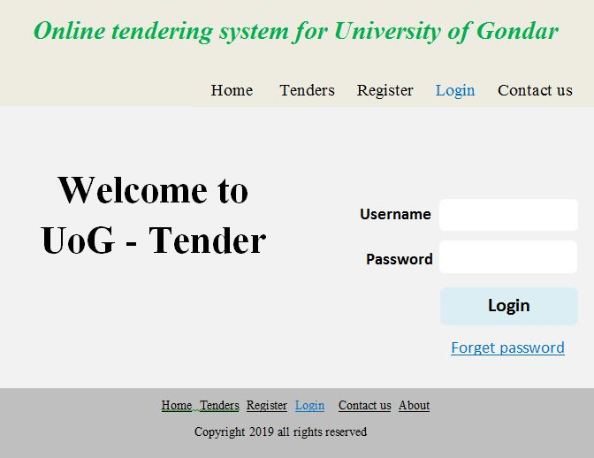

Figure 2‑13 User interface for login

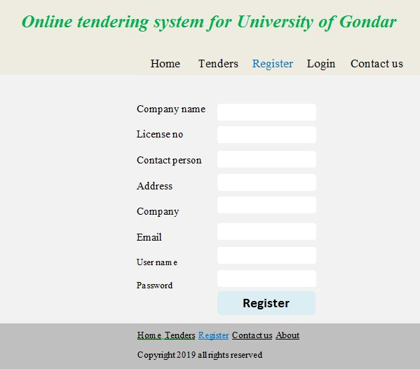

Figure 2‑14 User interface for registration

# CHAPTER THREE

# SYSTEM DESIGN

## Introduction

This chapter focuses on transforming the analysis model of the proposed system into design model. The problem domain gathered, requirements analyzed as user’s requirements in the previous document, will be properly defined to create a clear picture of solution domain. UML diagrams of the analyzing phase were used as a spring board to deal with design details which are supported by component, package, detailed class, and deployment diagrams.

We define the current and the proposed system software architecture and we specify design goals to improve the quality of the system by increasing usability of the system and reducing response time and operating cost. We describe about decomposition of the system into smaller manageable subsystems. We also specify the Hardware/software mapping by using deployment diagram, the persistent data management, and the access privileges of each actors using Access control matrix.

## Current software architecture

The current tendering system at University of Gondar is working manually due to this there is no system software architecture being used currently.

## Proposed software architecture

### Overview

The architecture is broadly defined to be the underlying structure of things []. In this system we use three tier architectures, these are client tier, middle tier and the data tier. The client tier is a client side application which provides the user interface to end user. Bidder, admin, purchasing officer, finance officer and professional can interact directly with the system through user interface. The middle tier is the class which works as a mediator to transfer data from client tier to data tier. The third tire is the data tier which is also a class to get or set data to the database queries back and forth.

Users can access the system by sending actions to the server through HTTP using web browser. Web server connects to the database to retrieve the requested data and sends response to the browser which displays the output on the web page.

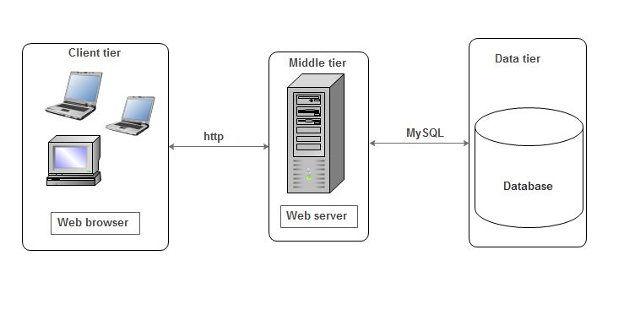

Figure 3‑1 Architecture of the Proposed System

### Subsystem decomposition

The online tendering management system is decomposed into simpler parts called subsystems in order to reduce the complexity of the solution domain. Subsystems are made of a number of solution domain classes.

The system decomposition includes:-

1. **Registration subsystem:-**This subsystem allows bidder registration, employee registration and business category registration.
2. **Tender subsystem:-**This subsystem allows purchasing officer to cancel tender, extend opening date, system automatically close tender, purchasing officer open tender and professional to select sample product.
3. **Document subsystem:-**This subsystem allows purchasing officer to upload tender document, evaluate Technical document and bidders to get tender document and place bid.
4. **Feedback subsystem:-**This subsystem allows the user to give feedback and admin to view user’s feedback for system modification.
5. **Administration subsystem:-**This subsystem allows the administrator to manage account and user to change password.
6. **Notification subsystem:-**This subsystem allows the bidder to get notification and view tender advertisement.
7. **Report subsystem:-**This subsystem allows the purchasing officer to generate report.

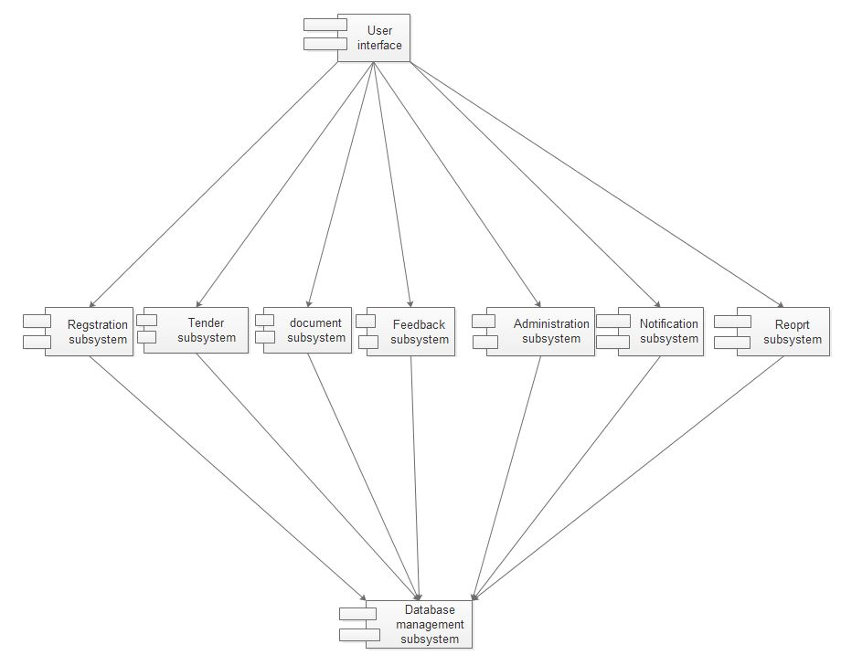

Figure 3‑2 Component diagram

### Hardware/software mapping

This section describes hardware/software mapping of the system. We use UML deployment diagram to diagrammatically depict the hardware/software mapping.

Deployment diagrams model the physical architecture of a system, and it shows the relationships between the software and hardware components in the system and the physical distribution of the processing []. The hardware and software needed for client side and server side are computer, server, scanner, browser software etc. The client program will communicate with the Application server through an HTTP connection and application server communicates with the database server through SQL.

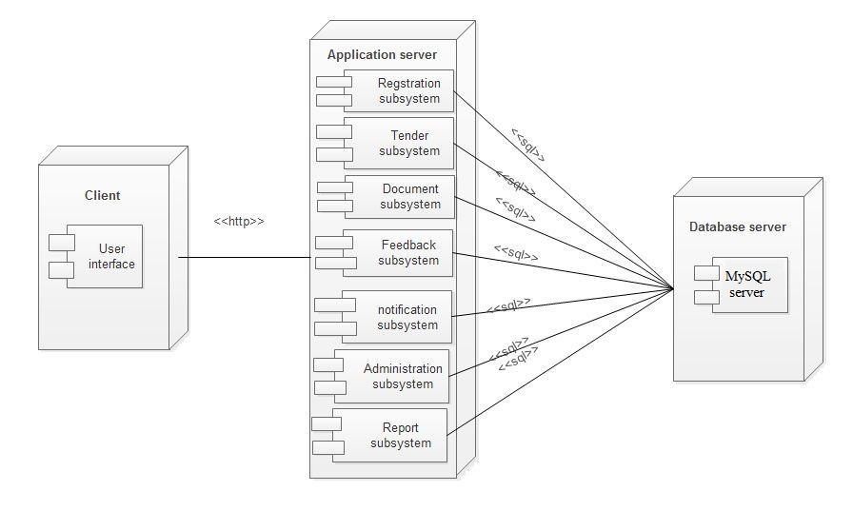

Figure 3‑3 Deployment diagram

### Persistent data management

Persistence data management is a diagram which used to communicate the design of the database, usually the database to both the users and the developers. It is also used to describe the persistence data feature of the system.

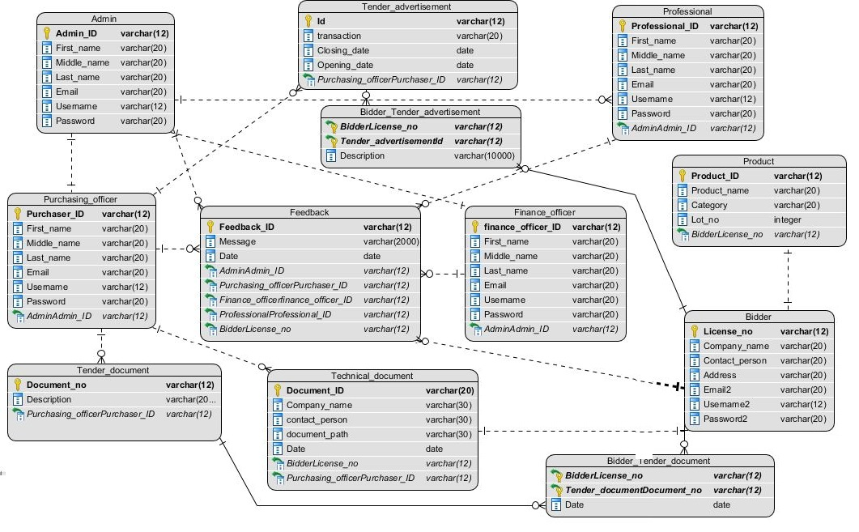

Figure 3‑4 E-R diagram

### Access control and security

Here clearly describe the way we will use to secure our system and the issues associated with access control within our system. We should also specify which actions are given to which user under what condition. Access to the system must be controlled by creating different authentication levels and using password for login purposes. Any people who have the authentication to use the system have to provide a username and password in order to perform what it supposed to do. We use hashing algorithm encryption mechanism to encrypt password, because hashing algorithm is one the most basic security consideration and it is very fast and accurate.

|  |  |  |  |  |  |
| --- | --- | --- | --- | --- | --- |
| Actor  Object | Admin | Purchasing officer | Bidder | Finance officer | Professional |
| Tender advertisement |  | Post | View |  |  |
| Tender document |  | Upload | Send request,  Download | View request |  |
| Business category | Add |  |  |  |  |
| Technical document |  | Evaluate | Submit |  |  |
| Feedback | View | Send | Send | Send | Send |
| Notification |  |  | View |  |  |
| Report |  | Generate |  |  |  |

Table 3.1 Access control matrix

### Subsystem services

This section describes the service provided by each subsystem.

1. **Registration subsystem:-**This subsystem is used for the following use case:-

* Admin register employees
* Bidder registration
* Admin add Business category

1. **Document subsystem:-** This subsystem is used for the following use case:-

* Purchasing officer upload tender document
* Bidders send tender document request
* Bidders download tender document
* Bidders place bid
* Purchasing officer evaluate Technical document

1. **Tender subsystem:-**This subsystem is used for the following use case:-

* Purchasing officer view bidder
* Purchasing officer cancel tender
* Purchasing officer extend opening date
* System automatically close tender
* Purchasing officer open tender
* Finance officer view request
* Professionals select sample
* User view result

1. **Feedback subsystem:-** This subsystem is used for the following use case:-

* Bidder send feedback
* Purchasing officer send feedback
* Finance officer send feedback
* Professional send feedback
* Admin view feedback

1. **Administration subsystem:-** This subsystem is used for the following use case:-

* Admin manage account
* Purchasing officer change password
* Finance officer change password
* Bidders change password
* Professional change password

1. **Notification subsystem:-** This subsystem is used for the following use case:-

* Purchasing officer post tender advertisement
* Bidders view tender advertisement
* Bidders view notification
* Time generate notification

1. **Report subsystem:-** This subsystem is used for the following use case:-

* Purchasing officer generate report

## Detailed Class Diagram

Detailed class diagram is a class diagram with visibility and signature specified for each attributes and operations []. In this class diagram we define which attributes and operations are private to that class, which attributes and operations can be accessed by the class decedents (protected), and which attributes and operations are publicly accessible by the class user (public).

In order to define the visibility of attributes and operations we use the following symbols:-

* (#) represents protected means elements are visible to elements that have a generalization relationship.
* (+) represents public means elements can access by every class.
* (-) represents private means elements access by its own class only.

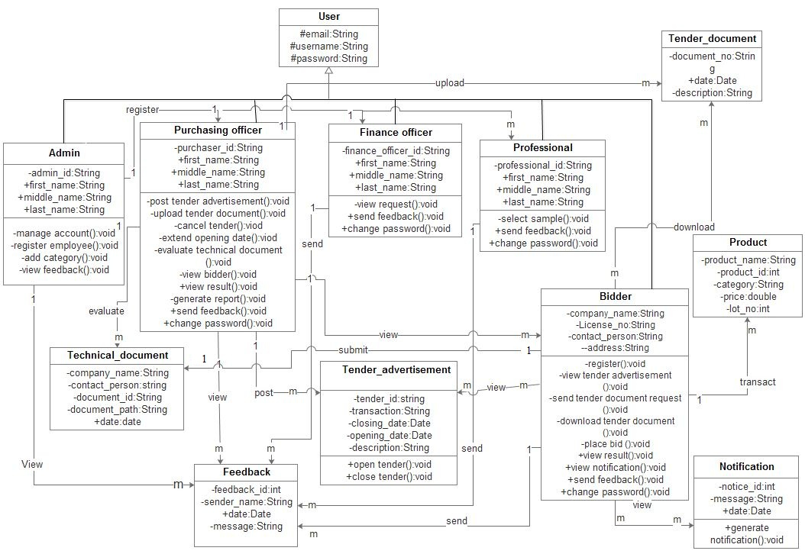

Figure 3‑5 Detailed class diagram

## Packages/Models

Package is UML construct that enables you to group together elements that are semantically related and might change together []. It is a general purpose mechanism to organize elements into groups to provide better structure for system model.

In this section we describe the decomposition of subsystems into packages. We group the subsystems into three packages.

1. Interface package layer is client tier that is user interface.
2. Application package layer is middle tier that contain subsystem.
3. Storage package layer is data tier that is database of the system.

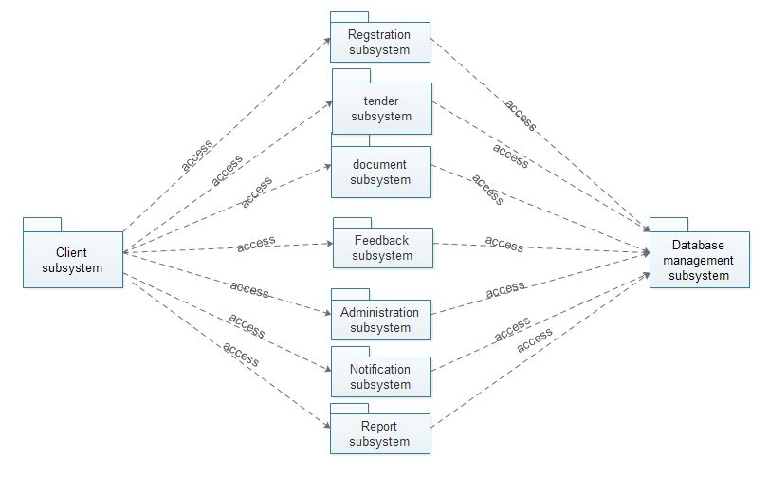

Figure 3‑6 Package diagram

# REFERENCE